K.Yamini Joshna

192110710

1. Develop a system using UML for implementing the Exam Registration Portal. It should verify the details of the candidate by the central computer. The details regarding the candidate will be provided to the central computer through the administrator and the computer will verify the details of the candidate and provide approval. Then the hall ticket will be issued from the office to the candidate.

**Use case diagram for exam registration portal:**

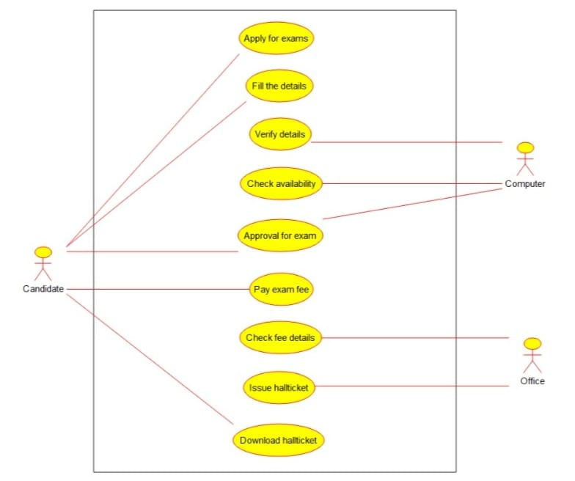

**Class diagram for exam registration portal:**

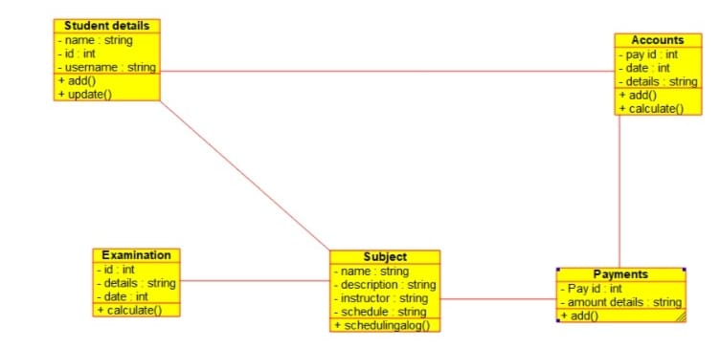

**Activity diagram for exam registration portal:**

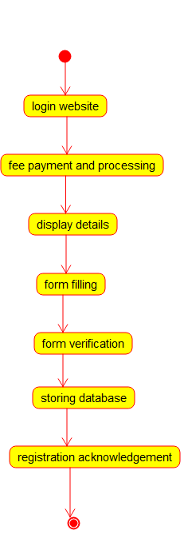

2. Develop a system using UML for implementing Stock Maintenance System. In this system, the customer can place orders and purchase items with the aid of the stock dealer and central stock system. These orders are verified and the items are delivered to the customer. Then the stock details are to be updated accordingly.

**Use case diagram for stock maintenance system:**

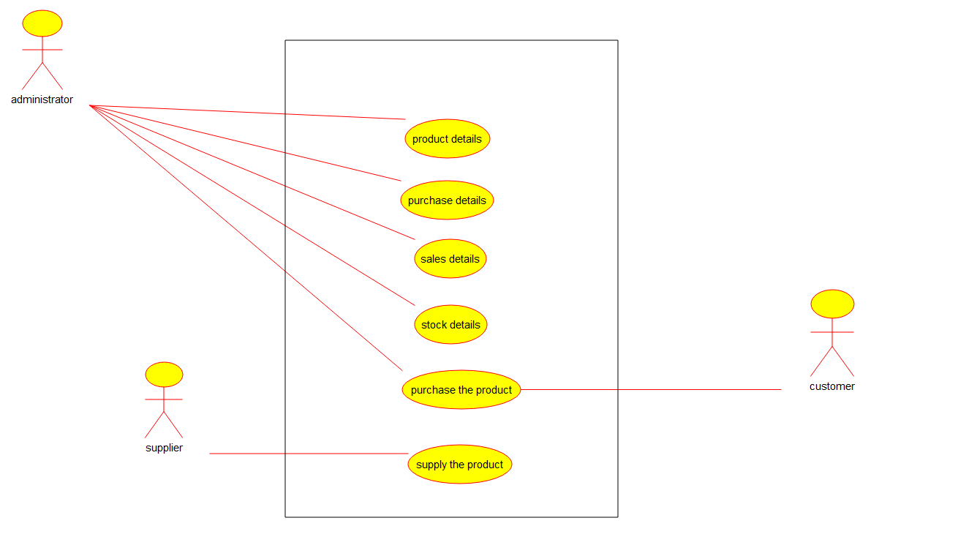

**Class diagram for stock maintanence system:** 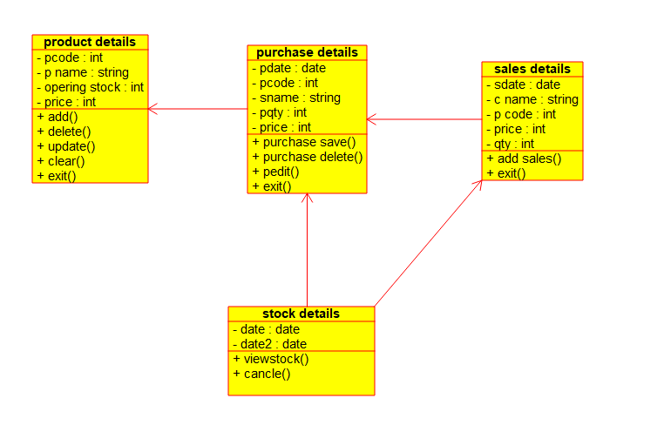

**Activity diagram for stock maintanence system:**

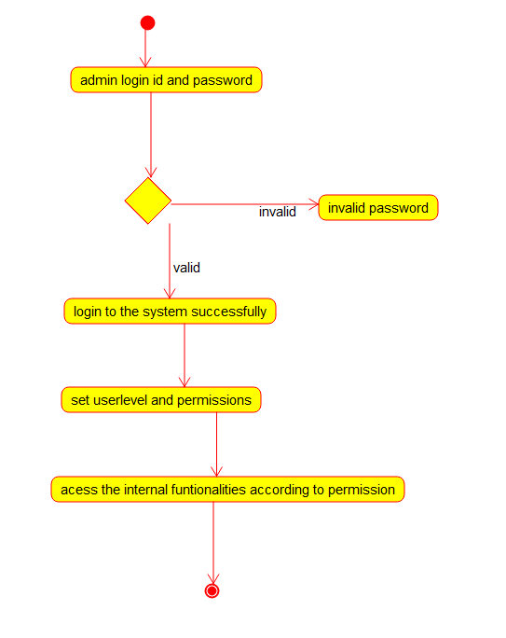

3.Develop a system using UML for implementing Online Course Reservation System. This system is organized by the central management system. The student first browses and selects the desired course of their choice. The university then checks the availability of the seat if it is available the student is enrolled for the course

Use case diagram online course reservation system:

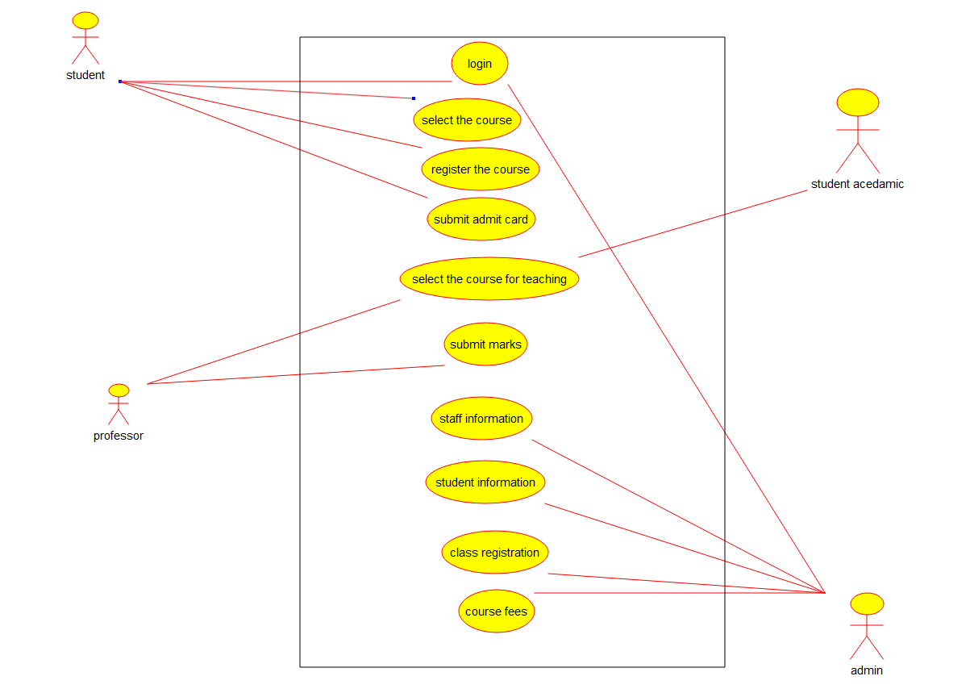**Class diagram for online course reservation system:**

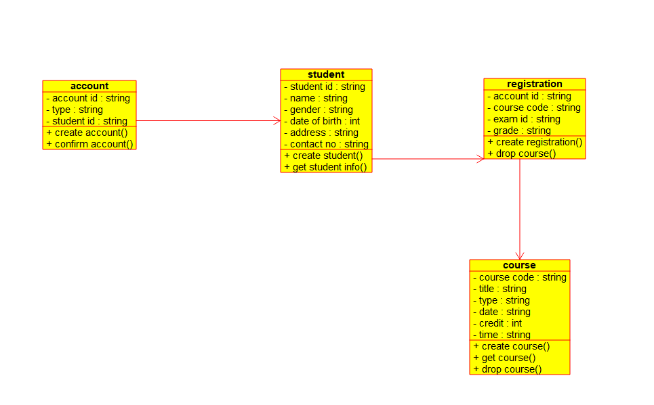

**Activity diagram for online reservation system:**

